ST2 Conflict Resolution

# Detecting Conflicts

A conflict occurs when a version in workspace has a created date that is earlier than the latest committed version and changes to its properties overlap.

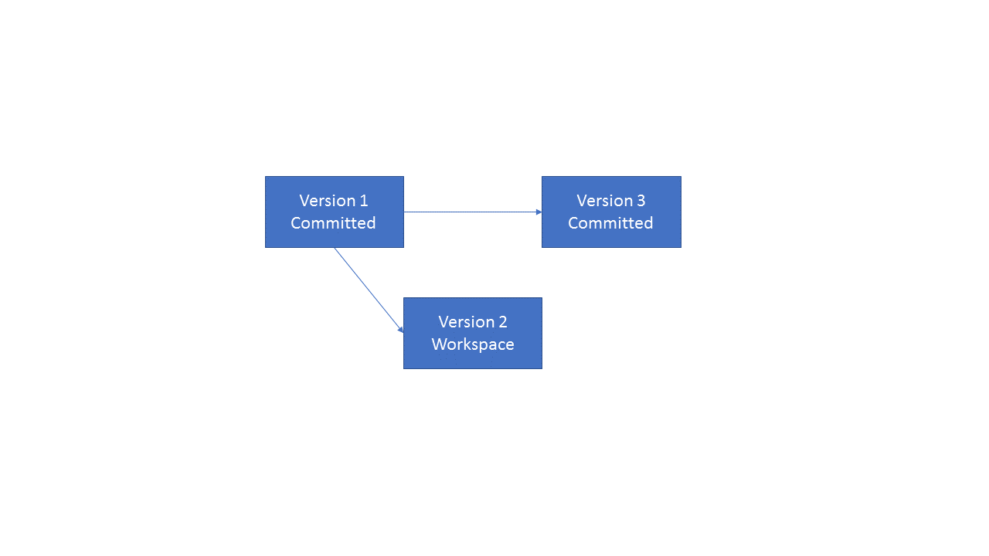

# Resolving a conflict

A conflict can then be resolved by comparing the version in workspace to the latest committed version and “merge” the values of the properties. This will create a new version that contains the result of the resolve.

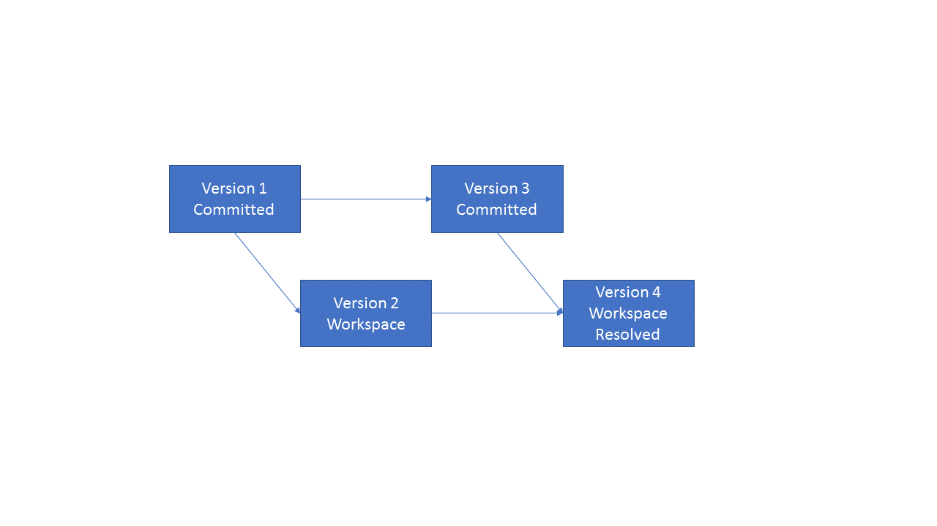

# Saving the new changes

The changes can then be committed (Both the workspace version and the resolve version) and they will appear after the version, with which the conflict occurred, in the order.

